A C H U R C H G U I D E F O R V I S I T O R S
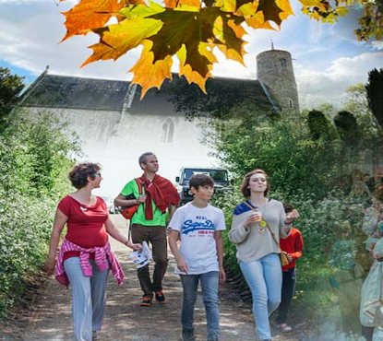

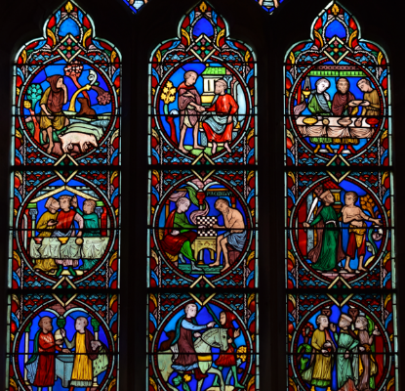
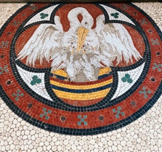
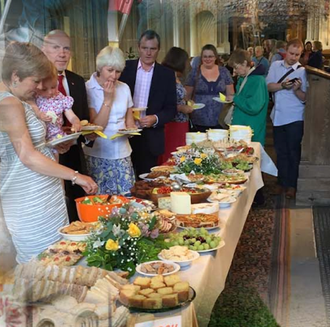
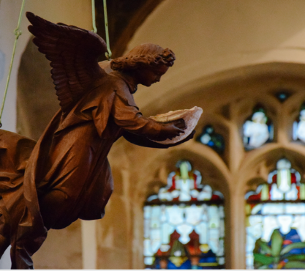

Welcome to ChurchName!

Thank you for visiting ParishChurchName today!
Please take this guide with you as you explore the architecture and history of this beautiful church. The booklet points you to the special treasures and features of the church building and its treasures accumulated over hundreds of years.
We hope you will find something special here.

www.YourChurchWebsite.co.uk

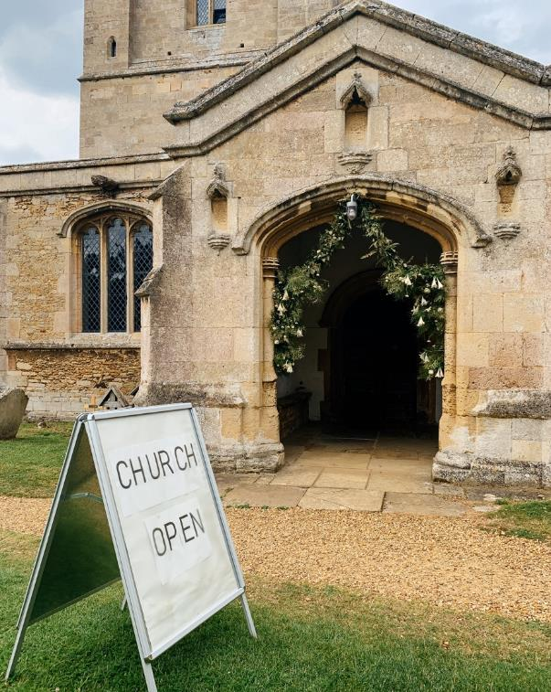
Insert here a message or a short welcoming letter from the vicar where s/he greets visitors and encourages them to explore the church and churchyard and enjoy their visit.
If you have a Friends group, this could include a message from the chair of the Friends group, to show the church works collaboratively with its local community.
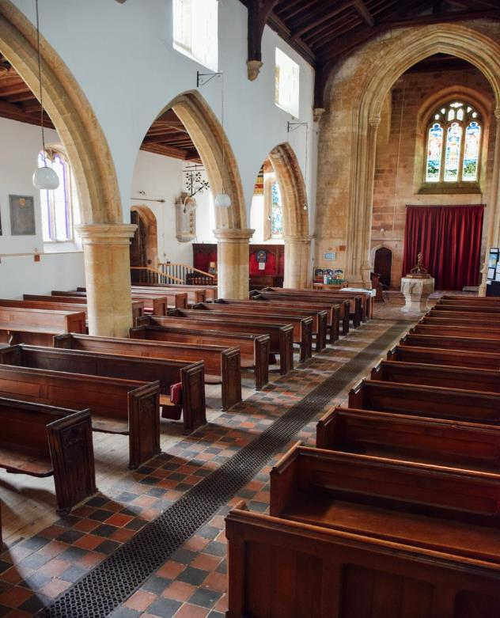

The opening of the guidebook – as a summary of your church – can mention what you are especially proud of and your hopes for the future of the church.
Do not forget to mention other churches in your Benefice or ministry to encourage visitors to see them too.
When inserting a new image, use the menu Insert > Pictures > Picture from File (or drag and drop). Then double-click on the image and select ‘Square’ in the Wrap Text option to lock its position.

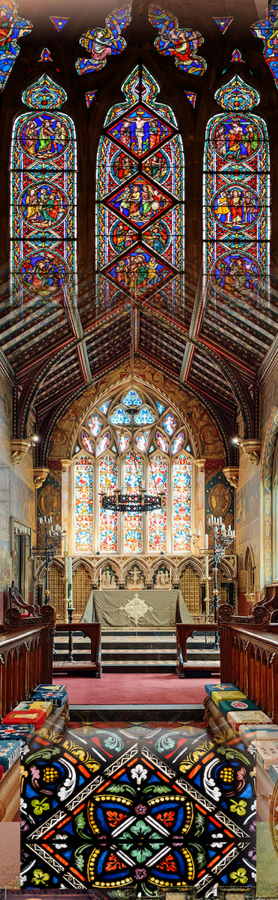

Brief History or
Timeline of History

This is a section where you might want to answer ‘Who are we?’ and write a short history of the church, land, the surrounding community and your village/town.
Alternatively, you might wish to list important dates in your church history alongside the dates and milestones of national historical events, e.g. Signing of Magna Carta, Coronation of Queen Victoria etc., which will help relate your church to major events.
As this is the guide to the church, it is advisable to keep the historical section short as long blocks of text can be off-putting.

Church Treasures

There is no preferred order of describing artefacts in the guidebook, however, the simplest way is to arrange them in the order in which a visitor would walk around the building, e.g. the church exterior, proceeding with the interior, and finally reaching the altar.

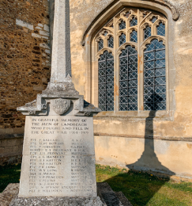
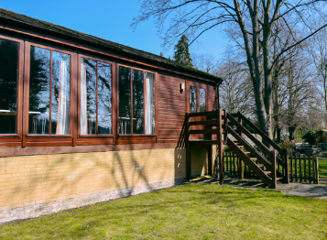
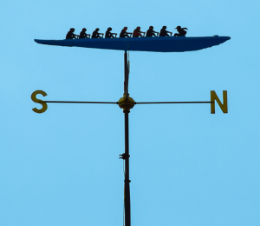
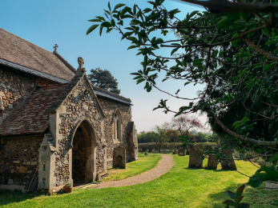
Church Exteriors

Memorials, e.g. war memorials Oldest headstones
Sculpture, e.g. Saxon sculpture Church window (architectural style) Quoin, i.e. an external angle of the church wall
Tower, spire, weathervane, tower clock
Roof, e.g. thatched roof
Roof decorations (the cross, animals etc)
Window decorations, glass Doorways and archways, e.g. a Norman doorway
Porch, extensions and additions Trees in the churchyard Community garden (see the next section)
Benchmarks and inscriptions on church walls
Church building material, e.g. stone, brick etc.
Scratch dials
Gargoyles
Memorial benches
Public footpath
Places of interest nearby, e.g. a dyke, a river, ancient monuments etc.

“
Insert a quote from the Visitors’ book (if you have one) or recent feedback from church visitors

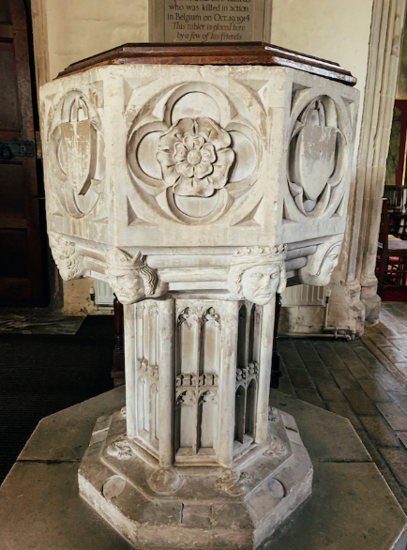
Church Interiors

The iron-bound parish chest is believed to be used…
The nave and aisles are Perpendicular…
The organ, built in 1851, was restored at the end of the 20th century…
Notice a fine mosaic of a pelican – a reference to Christ and a symbol of self-sacrifice…
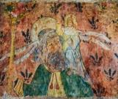
Proceed with some details in the nave. There are certainly a lot to tell, but be brief.
When entering the church, notice the blend of Victorian and medieval styles…
The bell chamber contains…
Look above: you can see a splendid array of wood carved angels…
Several wall paintings include 14th-century scenes from the Resurrection and remains of floral decoration.
The War memorial on the south wall…
A number of pews originating from around the 16th century with carved ends and finials…
Only a few pieces of stained glass remain, but there are some nice medieval fragments in the east window of the south aisle…

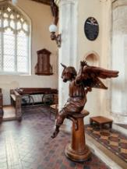
The East window is a memorial to Dr John Wright, surgeon, who must have been much admired by the donors…
A prominent feature is the Angel Lectern, carved in oak with extended wings, holding the book-rest, was described by architectural historian Nikolaus Pevsner.

Lead your visitors toward the chancel and High Altar.
The well-lit chancel – an example of the Decorated period – may have been the work of craftsmen from the Lady Chapel workshop at Ely…

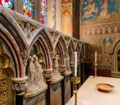
The chancel rood screen dates from the 15th or early 16th century with much original woodwork…
Walk around and notice floor plaques of…
Closer inspection of the rood screen reveals little faces and pinnacles decorations…
The chancel floor has the brass in memory of William Knight, Rector 1599–1623.
The choir stalls…The Sing Papworth choir usually gives a concert every year in the church…
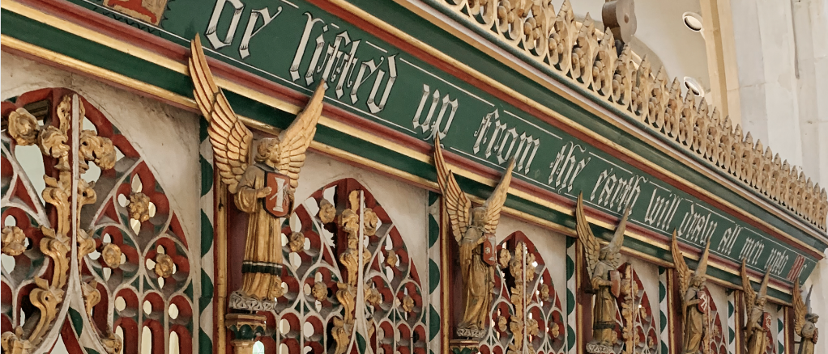
How many Saints can you count? Inspect the alabaster panelling in the sanctuary, inlaid behind the altar with figures of saints in mosaic, influenced by the Oxford movement…

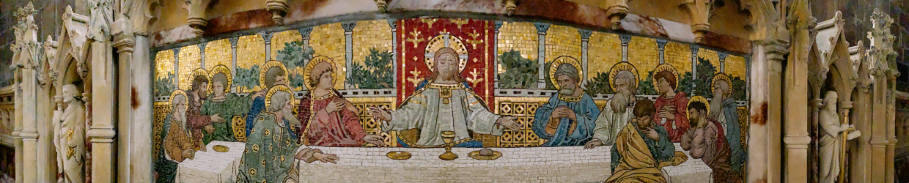

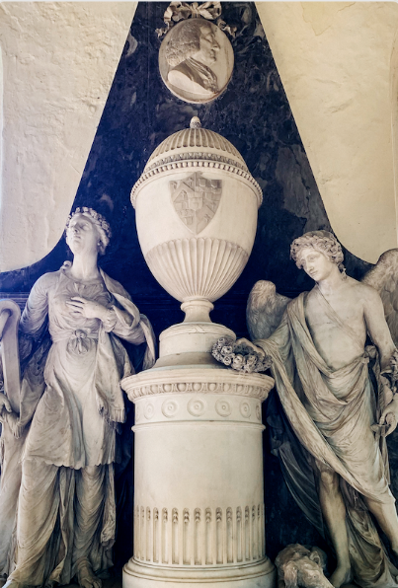
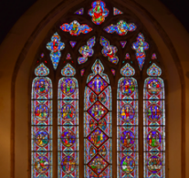
The stained glass windows, said to be East Anglia’s largest expanse of 19th century French cathedral glass, depict scriptural scenes, mainly from the New Testament…

The church hall is used for church events such as Sunday school, Pathfinders, Friday evening youth club, as well as various events by local community groups…
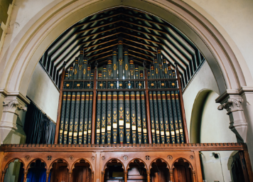
…
Floor mosaic
Commandment boards
Roof woodwork, e.g. angels
Roof, e.g. fan vault roof, wagon roof Mythical creatures, e.g. animals, Green Men, fertility symbols etc.
Pews, box pews, ‘horse box’ family pew Pew-end carvings
Kneelers, e.g. symbols and coat of arms on kneelers
Graffiti, wall marks, inscriptions and wall paintings
Font and font lid decorations
Holy Water stoup
Bells and inscriptions in bell chamber
Coats of arms (woodwork, in the stained glass window, on walls, on the ceiling) Carved stone archway in the wall, i.e. a memorial
Stonework, e.g. carved faces, ornaments, mutilated stonework and other signs of deliberate historic damage
Corbels and corbel figures
Medieval chest
Interior arcades
Rood screen
The organ
Wall paintings
Medieval brasses with effigies
Brass plates
Notable burials in the church, e.g. tomb slab Medieval coffin lid
Bier
Ledger stones and floor tablets
Pulpit and the reading desk
Wall memorials
“
Insert a quote from the Visitors’ book (if you have one) or recent feedback from church visitors

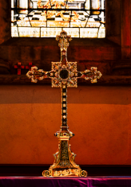
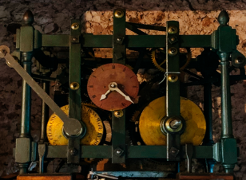
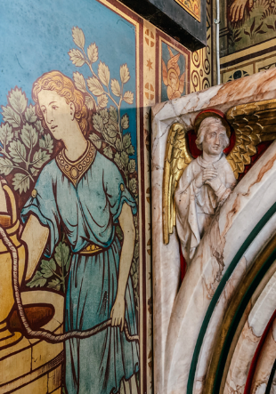
Vestry door
Priest door into the chancel
Plaques and floor plaques
Paintings and portraits
Lectern
Side chapels
Hymn board
Altar rails
Communion table
The Cross and cross shape
Tables, e.g. Jacobean tables
Easter Sepulchre
Altarpiece
Tabernacle
Windows and stained glass
Piscina
Sedilia
Chalice Church Plate (It is advisable not to mention valuable treasures in the church safe, e.g. silverware. If you must, you should say it is not kept in the church (even if it is!)
Choir stalls
Relics
Blind wall arcading
Traces of earlier restorations
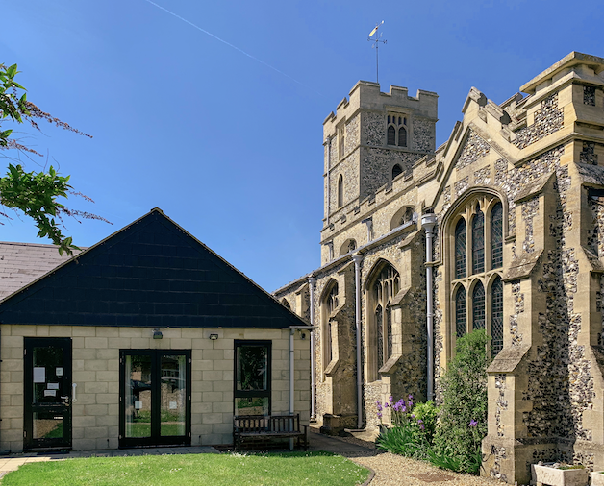
Church Hall
Describe briefly special treasures in the church hall, if there are any. Explain the purpose of the church hall and what events and activities are usually held there.
…
…

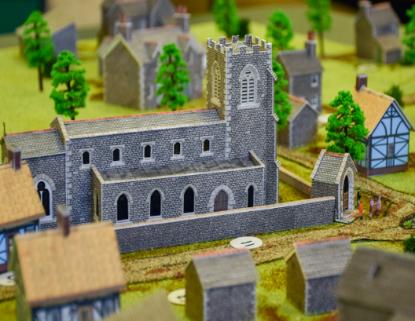
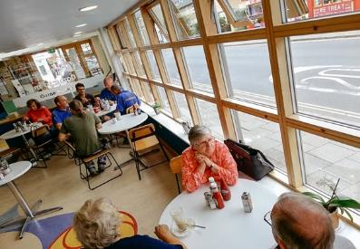
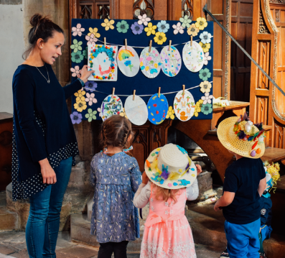
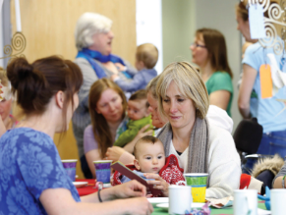
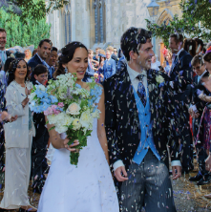
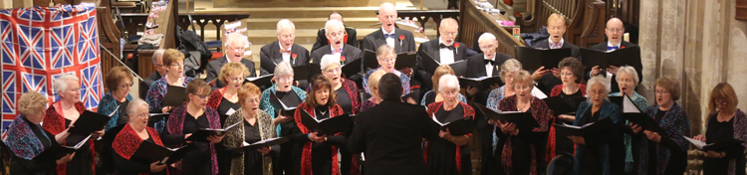

Insert images of people and activities in the church building(s). Additional information may feature:
What’s On, Church Café, Family Events

This church is open daily and provides a needed place of peace, reflection and private prayer. We offer various events and activities and services. Visit us (your church website) and follow on social media.
Church address, phone numbers, church/benefice website, A Church Near You website (if you have one), Friends of the church contacts (if established).
Include acknowledgements with thanks to everyone who helped develop and write your church guidebook.
We hope you have enjoyed your visit and will visit us again!
Insert QR code
Please spare some change to support this cherished church building. Give instruction where to find the collection box, a contactless terminal, or refer to online giving by text or QR code (if available).
Sample photos source: REACH Ely case studies.

