Ely Diocese Collective Worship Theme Plan Exemplar – Saints – 17 Weeks
Week by Week Template
- Saints defined
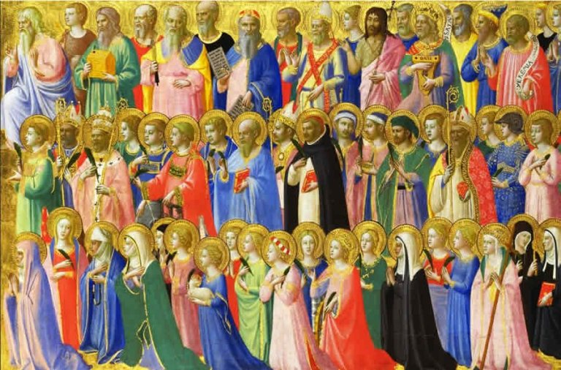
- St Matthew
- St Mark
- St Luke
- St John
- Mary Magdalene
- St Michael
- St Constantine
- St Jerome
- St Augustine
- St Francis of Assisi
- St Claire of Assisi
- St Patrick
- St David
- St George
- St Andrew
- St Peter

Week no | Theme  ‘Saints’ | Suggested Choral Worship | Core Story | Church Values | Other Themed Links | Bible stories  Things to note
1 | What is a Saint?  How do you become one? | You are God  AllStars Kids Club | School namesake Saint or one connected with local Churches  What is the definition of a Saint? | Connect to your school/local church | School Vision
2 | St Matthew  Patron Saint of Tax Collectors and Accountants | God, You’re Good to Me  Vineyard Worship UK & Ireland | Jesus’ apostle  Witness of Jesus’ ascension  (Luke 24:50,  Acts 1:10–14)  Tax Collector  Gospel – written for the Jews, Matthew’s first in the NT  Viewpoint: Jesus is the King of the Jews, Messiah | Faith  Trust  Friendship | Belief  Discipleship | Feast day  21st September
3 | St Mark  Patron Saint of Lawyers, Opticians, Pharmacists, Painters, Secretaries, Interpreters | He says that you’re amazing  Grum Carrington | Gospel – is the shortest, about Jesus’ ministry especially miracles  Last Supper at Mark’s house  Sent on missionary to spread the word of Jesus  Became a Bishop sent to Egypt  Died a martyr | Faith  Perseverance  Trust  Service  Koinonia | Martyrdom | Feast day  25th April
4 | St Luke  Patron Saint of Painters and Physicians | This is amazing love  Phil Wickham | Author of third gospel and Acts of the Apostles  Wrote for the Gentiles (non Jewish people)  Luke was a doctor  Jesus is the son of God  Parables, miracles and stories of healing  Missionary with St Paul | Faith  Friendship  Service  Koinonia  Hope  Kindness | Healing  Miracles | Feast day  18th October
5 | St John  Patron Saint of Authors, Love, Loyalty and Friendships | Our Father  Bethel Live | Jesus’ youngest apostle  Writer of the gospel and 5 other books in the NT  Disciple of John the Baptist  Jesus is the Lord  Symbolic gospel: John 1 Creation  Last surviving apostle, not martyred | Faith  Compassion  Friendship  Service  Hope | Discipleship  Confidence  Outspoken | Feast day  27th December
6 | St Mary Magdalene  Patron Saint of Women | Story of the cross  Rend Collective | In all 4 gospels  Female follower of Jesus  Witness of crucifixion, burial and resurrection John 20:10-18  Tells the disciples Jesus is risen  Only woman except Mary Mother of Jesus to have a feast day  Leader of the women followers | Faith  Friendship  Trust  Hope  Courage | Belief | Feast day  22nd July
7 | St Michael  Archangel  Patron Saint of Police, Fire people and the Military | Our God is a great big God  Kidz Klub Brighton and Hove | Revelation (20:1-3)  The Battle in Heaven – God vs Lucifer | Faith  Excellence  Courage | Victory  Good / evil  Bravery  Strength | Feast day  29th September
8 | St Constantine | I’ve got the power  Young Voices Children’s Choir | First Roman emperor to convert to Christianity  ‘Dream’ of the cross  ‘Chi Ro’ | Faith  Perseverance  Responsibility  Courage  Trust | Being a leader  Standing up for your beliefs | Feast day  21st May
9 | St Jerome  Patron Saint of Librarians, Scholars, Students and Translators | I’m gonna jump up and down  Doug Horley | Prayer -Conversion  1st Monastery in Bethlehem  Translated the OT Bible into Latin | Faith  Resilience  Responsibility  Wisdom  Koinonia  Courage | Changing your behaviour  Finding God  Hebrew - Latin | Feast day  30th September
10 | St Augustine  Patron Saint of  Printers and Theologians | Tusimyee  Watoto Choir | Christianity moving across to England  Baptised 1000s on Christmas day  Bishop-Archbishop | Faith  Responsibility Resilience  Perseverance  Koinonia | Spread of Christianity  Confidence | Feast day  26th May
11 | St Francis of Assisi  Patron Saint of Animals and Nature | Super Wonderful God  Yancynotnancy | First outside Nativity scene  Devotion to the Holy Communion | Faith  Friendship  Compassion  Gentleness | Animals  Care  Pet blessing | Feast day  4th October
12 | St Clare of Assisi  Patron Saint of TVs and Computers | Every move I make  CJ & Friends | Follower of St Francis  Founder of ‘Order of Saint Clare’  Rule of life – monastic rules for women  ‘Married’ to Christ | Faith  Friendship  Compassion | Dedication | Feast day  11th August
13 | St Patrick  Patron Saint of Ireland and Engineers | Be Strong and Courageous Sea Shanty Doug Horley & Mark Read | Slave in Ireland  Escaped to England  Became a priest and travelled back to Ireland  Preached about God to Irish people  Shamrock – Trinity | Faith  Resilience  Perseverance  Koinonia | Prayer  Conversion of the Irish to Christianity | Feast day  17th March
14 | St David  Patron Saint of Wales | Hope  AllStars Kids Club | Welsh Priest  Founded a Monastery – very strict life  Cultivation  Preached with white dove on shoulder  Leeks - battle | Faith  Service |  | Feast day  1st March
15 | St George  Patron Saint of England  Soldiers, Archers, Butchers, Farmers and Boy scouts | My God is so big, so strong, so mighty  Powerkids | Stood up for Christians in the Roman army- arrested  Martyred for his beliefs  First Crusade in Jerusalem | Faith  Courage  Trust  Compassion  Responsibility  Justice | Protection  Bravery  Willing to protect innocent lives  Symbol of the Order of the Garter | Feast day  23rd April
16 | St Andrew  Patron Saint of Scotland | Superhero  Mannahouse Kids | First called disciple  Fishers of men  Disciple of John the Baptist before Jesus  ‘X’ shaped cross for crucifixion – Symbol of the Scottish flag | Faith  Friendship  Trust  Service  Courage  Responsibility | Brother of St Peter | Feast day  30th November
17 | St Peter  Patron Saint of Popes and Rome | House of the Lord  AllStars Kids Club | Known as Simon Peter in the Bible  First called disciple  Fishers of men  Frequently in NT  Died by crucifixion – upside down  Keys to Heaven (Matthew 16:19) | Faith  Friendship  Trust  Service  Responsibility | Brother of St Andrew  Discipleship | Feast day  29th June

