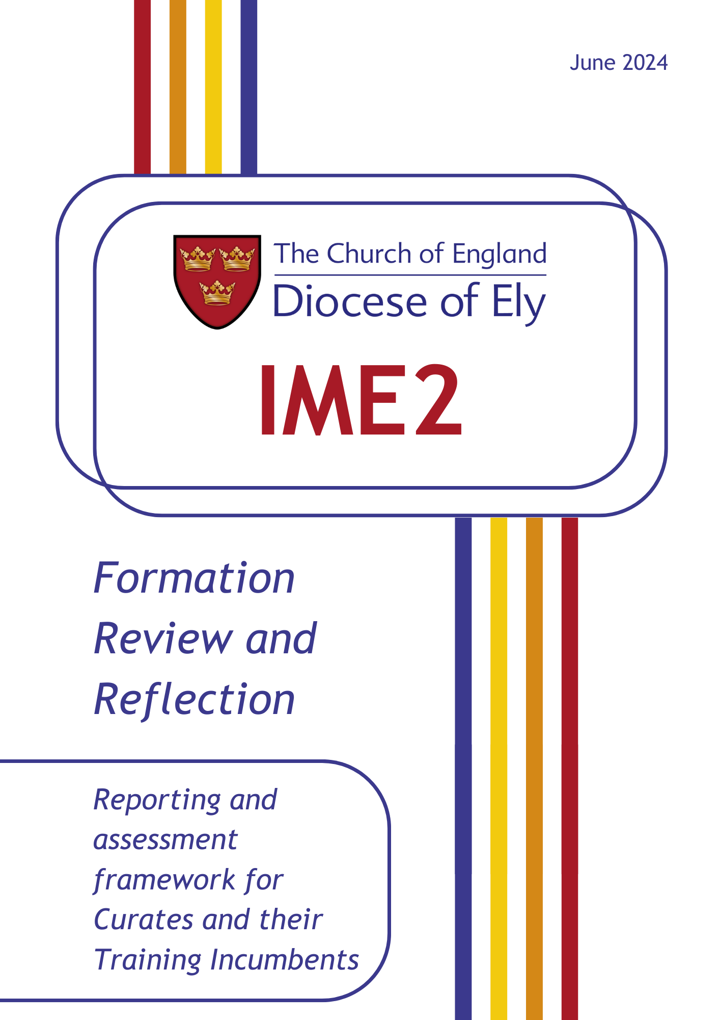
Qualities to be inhabited  (summarised from the Church of England’s ‘Formation Criteria for Ordained Ministry’) | 1. Does not yet inhabit the quality competently - no potential to do so | 2. Does not yet inhabit the quality competently - potential to do so | 3. Inhabits the quality competently, possible limitations for CMD to address | 4. Inhabits the quality well and comfortably | 5. Inhabits the quality very well / expertly
- Love for God
Christ: Is reliant on God – Father, Son and Holy Spirit - and lives out an infectious, life-transforming faith
Church: Is rooted in scripture, the worship of the Church and the living traditions of faith
World: Whole-heartedly, generously and attractively engages with God’s world
Self: Is prayerful and studies the Bible
Curate Comments and Reflection:

Training Incumbent Comments:

Qualities to be inhabited  (summarised from the Church of England’s ‘Formation Criteria for Ordained Ministry’) | 1. Does not yet inhabit the quality competently - no potential to do so | 2. Does not yet inhabit the quality competently - potential to do so | 3. Inhabits the quality competently, possible limitations for CMD to address | 4. Inhabits the quality well and comfortably | 5. Inhabits the quality very well / expertly
- Call to Ministry
Christ: Responds to the call of Christ to be a disciple
Church: Understands the distinctive nature of ordained priestly ministry
World: Is committed to being a public and representative person
Self: Articulates an inner sense of call grounded in priestly service
Curate Comments and Reflection:

Training Incumbent Comments:

Qualities to be inhabited  (summarised from the Church of England’s ‘Formation Criteria for Ordained Ministry’) | 1. Does not yet inhabit the quality competently - no potential to do so | 2. Does not yet inhabit the quality competently - potential to do so | 3. Inhabits the quality competently, possible limitations for CMD to address | 4. Inhabits the quality well and comfortably | 5. Inhabits the quality very well / expertly
- Love for People
Christ: Welcomes Christ in others, listens, values and respects; cares for those in poverty and the marginalised
Church: Builds relationships which are collaborative and enabling
World: Shows God’s compassion for the world
Self: Has empathy and is aware of how others receive them
Curate Comments and Reflection:

Training Incumbent Comments:

Qualities to be inhabited  (summarised from the Church of England’s ‘Formation Criteria for Ordained Ministry’) | 1. Does not yet inhabit the quality competently - no potential to do so | 2. Does not yet inhabit the quality competently - potential to do so | 3. Inhabits the quality competently, possible limitations for CMD to address | 4. Inhabits the quality well and comfortably | 5. Inhabits the quality very well / expertly
- Wisdom
Christ: Is inquisitive, curious and open to new and lifelong learning
Church: Shows Leadership that enables thriving and healthy churches, handles conflict, and can lead in mission
World: Is robust and courageous and prepared to take risks
Self: Is a mature and integrated person of stability and integrity
Curate Comments and Reflection:

Training Incumbent Comments:

Qualities to be inhabited  (summarised from the Church of England’s ‘Formation Criteria for Ordained Ministry’) | 1. Does not yet inhabit the quality competently - no potential to do so | 2. Does not yet inhabit the quality competently - potential to do so | 3. Inhabits the quality competently, possible limitations for CMD to address | 4. Inhabits the quality well and comfortably | 5. Inhabits the quality very well / expertly
- Fruitfulness
Christ: Embraces the different and enables others to be witnesses and servants
Church: Shows the capacity to exercise sacramental, liturgical and effective and enabling teaching ministry
World: Shares faith in Christ and can accompany others in their faith
Self: Has resilience and stamina
Curate Comments and Reflection:

Training Incumbent Comments:

Qualities to be inhabited  (summarised from the Church of England’s ‘Formation Criteria for Ordained Ministry’) | 1. Does not yet inhabit the quality competently - no potential to do so | 2. Does not yet inhabit the quality competently - potential to do so | 3. Inhabits the quality competently, possible limitations for CMD to address | 4. Inhabits the quality well and comfortably | 5. Inhabits the quality very well / expertly
- Potential
Christ: Grow in faith and be open to navigating the future in the company of Christ
Church: Manage change, and see the big picture
World: See where God is working in the world and respond with missionary imagination
Self: Be adaptable and agile
Curate Comments and Reflection:

Training Incumbent Comments:

Qualities to be inhabited  (summarised from the Church of England’s ‘Formation Criteria for Ordained Ministry’) | 1. Does not yet inhabit the quality competently - no potential to do so | 2. Does not yet inhabit the quality competently - potential to do so | 3. Inhabits the quality competently, possible limitations for CMD to address | 4. Inhabits the quality well and comfortably | 5. Inhabits the quality very well / expertly
- Trustworthiness
Christ: Follows Christ in every part of their life
Church: Leads maturely which promotes safe and harmonious Christian communities
World: Lives out their life as a representative of God’s people
Self: Articulates an inner sense of call grounded in priestly service
Curate Comments and Reflection:

Training Incumbent Comments:

