Cambridgeshire Churchyard Conservation Award - example of a management plan 2025.
Grassland and wildflower areas | Illustration | Description  It is very important to establish a good understanding and cooperative relationship with those who mow the grass. | Management Summary | Planting Ideas and comments
Long grass  Summer flower area  (3 points) | 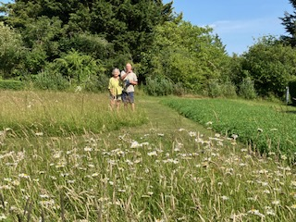 | Summer meadow, left as long grass throughout the summer. Must have at least partial sun.  Introduce grass snake shelter with corrugated iron placed in long grass area with pile of cut grass for nest. 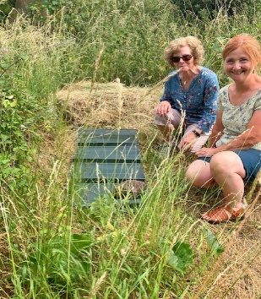 | Mow in February or early March, in late July/August, to emulate traditional hay meadows. Final cut in October, if possible. All mowings to be removed. (Ties in with No Mow May.) | Allow natural regeneration of existing native plants for first 2 years but introduce yellow rattle to help reduce the grass and sow seeds well before the winter. Could also introduce native wildflower seeds, from local verges or wild areas.
Short Grass  (1 point) | 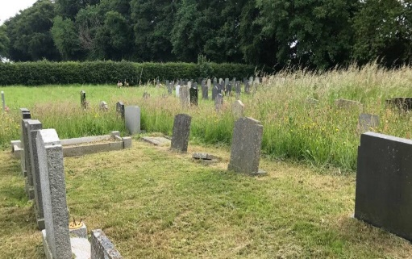 | Short grass, principally for community amenity use. And well visited graves.  These are lawn type areas but small plants will flower between cuttings. | Cut regularly throughout growing season; every 2 or 3 weeks between April and mid-October. Not cut in dry weather. All mowings to be removed, if possible. | Consider occasionally mowing round unusual or interesting species (such as hoary plantain, below) if appropriate.  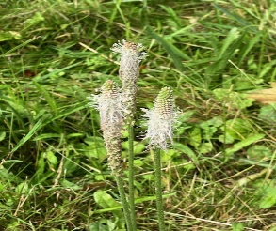
Uncut grass area  (2 points) | 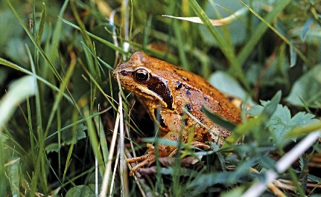 | Left totally uncut to act as cover for small mammals, amphibians, overwintering butterflies. At least some in a sunny position. | Leave indefinitely but may change area on a 2 or 3-year rotation. | Create a specific area or, alternatively, leave uncut grass round compost heaps, log piles and borders.
Medium grass  Spring flower area  (3 points) | 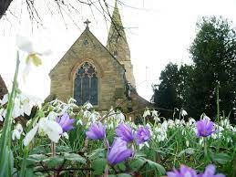  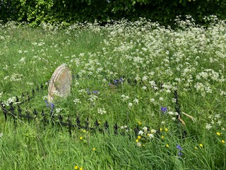 | When bees emerge in early spring, they desperately require early spring flowers to survive.  Spring wildflower area (e.g. clover, sweet violet, speedwell, lungwort, primrose, celandine) and bulbs such as bluebells, wood anemone, grape hyacinths, crocus). | Cut monthly from May to October, after flowers have finished and set seed. All mowings to be removed. Planting in clumps looks better and helps pollinators find flowers. | Initially, allow natural regeneration of existing spring flowers but plants such as native primrose, snowdrop, cowslip, crocus, winter aconite, bluebell, can be introduced. N.B. Daffodils look good but most are highly bred and have little pollen although bumblebees will visit wild daffodils (Narcissus pseudonarcissus).
Efforts to develop wildflowers and reduce coarse grasses  (2 points) | 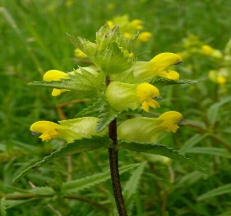 | Reduce grass by collecting all mown grass and by planting yellow rattle seeds in autumn. (Seeds must reach very low temperatures to germinate.) | Scrape semi bare patches in summer flower area for sowing yellow rattle. | Yellow rattle is semi parasitic on grass so helps reduce grass content in wildflower areas and helps wildflowers to flourish.
Nettle patch  in a sunny position.  (2 points) | 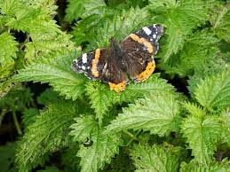 | Nettles are important foodplants for a variety of species of butterfly, moth eggs and their caterpillars | Some nettles must be in a sunny position.  (Possibly site an information notice next to nettle patch, to explain their importance) | Stinging nettles support at least 40 insect species, in addition to butterflies and moths. The flowers also provide seeds for birds later in the year.
No use of chemicals or herbicides  (2 points) | 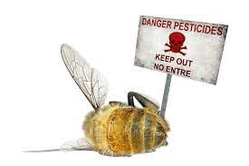 | Routine use of chemicals harms birds, earthworms, hedgehogs, frogs, plants and other wildlife | Routine use of chemicals harms birds, frogs, earthworms, hedgehogs, plants and other wildlife.
Paths through grassland | 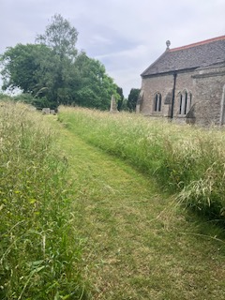 | Paths cut through or round flowery grassland areas. | Paths allow visitors to enjoy the wildflowers, delineate the different areas and confirm that the churchyard is being managed.
Mature ivy  Leave wherever possible, in sunny areas (2 points) | 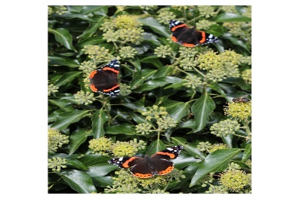 | 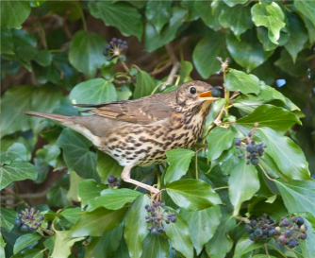 | Mature Ivy is a rich source of pollen for insects, including butterflies, bees and hoverflies and provides birds with berries later in the year. | N.B. ivy takes 10 years to mature so clumps should be left wherever possible.
Area of herbs and seed-bearing plants, left over winter  (2 points) | 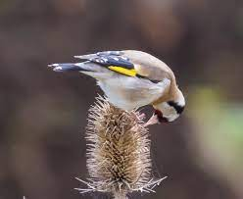 | Herb border, with plants to attract pollinators and feed birds in winter. | Manage annually, as required, to prevent plants from becoming woody or top-heavy. | Examples: lavender, heathers, rosemary, borage, oregano, teasels
Trees | 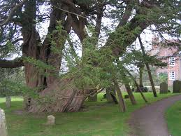 | Mature trees well maintained (2 points)  New plantings well cared for (1 point) | Check safety every 2-3 years  Make static log and brushwood piles from dead trees and branches | Any new planting will be native species, provide pollen and berries/fruit for birds and not shade summer flower areas. Can plant spring flowers under the trees - celandine, wild garlic, crocus,
Hedging and shrubs | 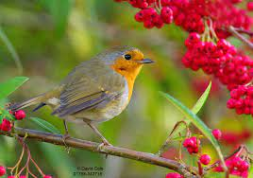 | Attractive to insects, provide berries for winter feeding and sites for nesting birds. |  | Hedging plants can include native hawthorn, beech, spindle, blackthorn, hazel, holly, field maple, buckthorn, buddleia.
Water  (2 points) | 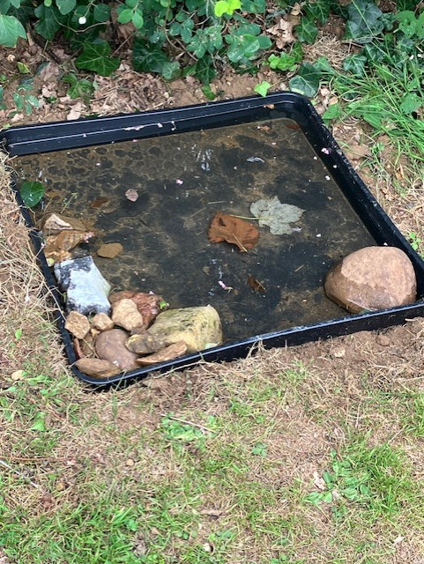 | Crucial for wildlife. Provide bowls or trays for bathing birds, small mammals and insects.  Rota to top up water regularly, especially in dry weather. | Plant trays are useful, with a stone to prevent insects drowning. | 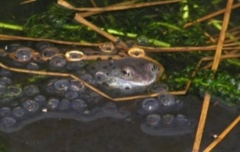  A few churches have installed small ponds but the faculty process can be long, so not required for the Award.
Composts  (1 point) | 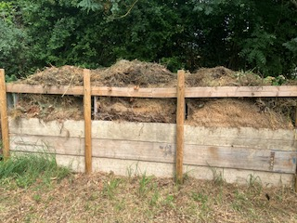 | Heaps of grass cuttings, twigs and dead flowers from graves. | Must be in a partially sunny spot, away from walls, to avoid damage. No need for a Green Bin. | For grass mowings and small  woody cuttings. Can build a compost container with pallets.
Log or brushwood pile  (1 point) | 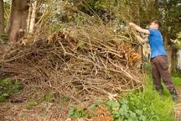 | Plenty of wildlife makes its home in dead wood and uses it as a source of food or for hibernation.  Logs and branches up to 1 m length in piles up to 600 mm high. Some in a dampish spot. | 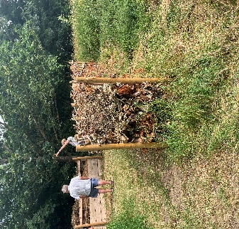 | In woodlands, fallen wood occurs naturally and many species have adapted to use this habitat. Fallen or dead wood can make a deadwood hedge.
Stumpery  (1 point) | 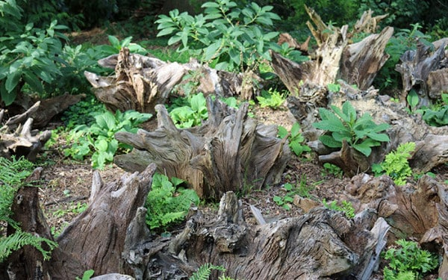 | Stumperies are made up of old tree roots, stems and stumps of trees. These can be combined, to offer a space for wildlife. Ideally place in a shady corner, with some in partial sunlight. | Leave undisturbed. Could plant ivy, to partially cover logs or spring flowers at base. | Use materials that may otherwise be wasted. Stand logs closely together in a vertical position, half buried in soil. Pack soil between the gaps to bury the bases of the logs. These will support species like stag beetles that like damp, submerged dead wood.
Variety of habitats
Bird boxes (or nesting sites)  bat boxes (or bats using building), insect hotels, badger entrances, bees in stone work  Various points | 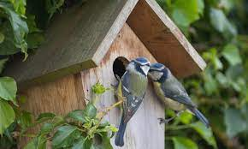 | Constructions such as bat, swift or bird boxes, bird baths, insect hotels.  Nest boxes ideally need to be cleaned out in winter. | The nest box entrance hole size effects the species attracted: 25 mm for blue, coal and marsh tits, 28 mm for great tits, tree sparrows and pied flycatchers, 32 mm for house sparrows and nuthatches. | Could consider visiting Landbeach or Swaffham Bulbeck church to see inhabited swift boxes.  All wildlife should be celebrated in the churchyard wherever possible.
Sustainability  Water butts or similar in use  (2 points)  No plastic flowers (2 points) | 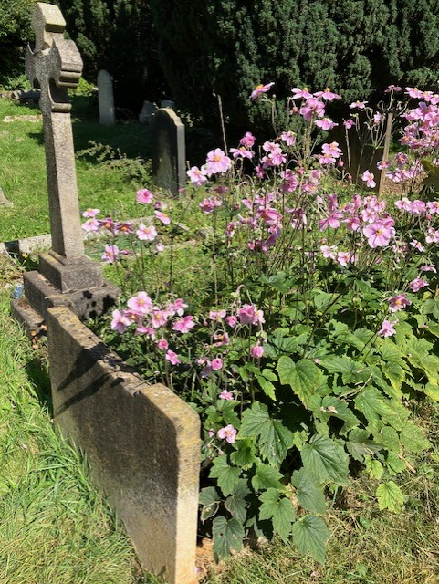 | Introduce policy of no plastic flowers but allow planting on graves of native species. | It is recognised that a no plastic flowers policy may be very difficult to introduce in some cases. | Consider installing water butts or similar.  Encourage people to adopt a grave and plant with native drought resistant plants.
Management, communication and public involvement | 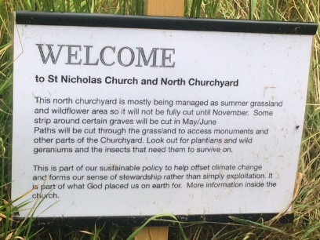 | Notices to explain the management of grassland and other features, such as nettles.  Notices placed in specific areas, as appropriate. Free posters from Caring for God’s Acre.  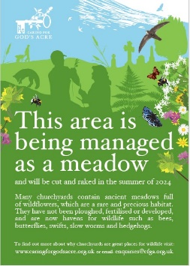 | Encourage others to help rake cut grass or help survey wildlife such as wildflowers, butterflies, mammals or birds. Publicise Churchyard Conservation Award and provide a seat for quiet contemplation | Spread the word about biodiversity to the local community. Consider using  Cambridgeshire Mammal Group to help conduct survey of mammals  https://www.cambsmammalgroup.org.uk/
Recording and Surveys | 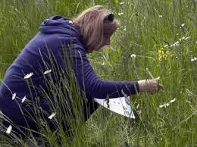 | Annual or biannual identification and location of living things – plants, flowers, butterflies, moths and other insects, small mammals, birds | Record any increase in numbers and status such as rarity | Try looking for local knowledgeable people to help.  Cambridgeshire Mammal Group can help with small mammal surveys, such as hedgehogs.  Cambsmammal@gmail.com
Sketch plan of churchyard | 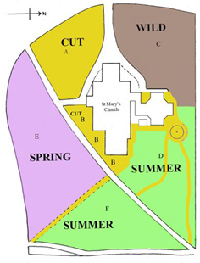 | A simple sketch map showing different grassy areas, paths and trees. | Essential for whoever mows the grass.
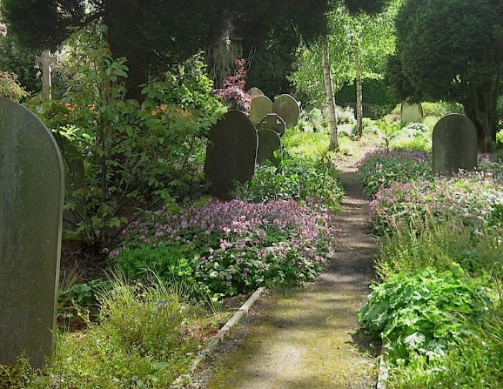
Bronze Award: 15 points, to include 10 from the Grassland section.
Silver Award: 25 points, to include 15 from the Grassland section.
Gold Award: 40 points to include meeting all the points from the Silver Award.

Caring for God’s Acre - for very useful resources and ideas. https://www.caringforgodsacre.org.uk/
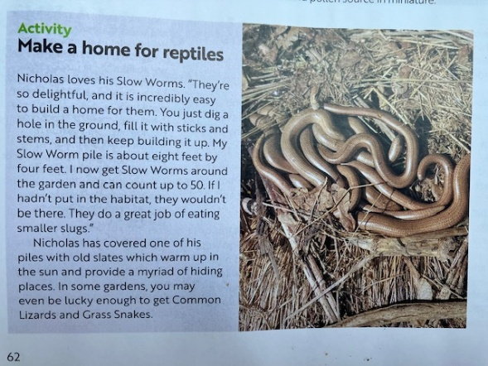
The Quiet Garden Movement. Quiet Gardens are special places created for contemplation, prayer, stillness and rest. They help promote the spiritual, mental and physical well being of those who use them.
Not all Quiet Gardens are found in churchyards, although the latter can be very suitable locations. Quiet Gardens have some seating and may be partially enclosed by trees, shrubs and flowers. The website provides more information. https://quietgarden.org/

