# Parish Code of Conduct:

A template for Parishes

The Bishop's Council invites the PCCs to adopt this Code of Conduct and to reflect on it regularly, at least every 2 years.

*This policy was approved by the PARISH PCC on Day Month Year*

The review period for this policy is **2 years**.

Review Date: Month Year

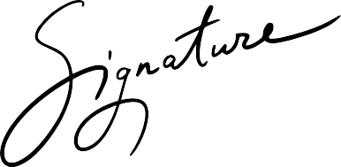

Parish Code of Conduct

**The fruit of the Spirit is**

**love, joy, peace, patience,**

**kindness, generosity, faithfulness,**

**gentleness and self-control.**

This Parish seeks to provide safe spaces where all can flourish.

We all share a responsibility in helping to achieve this and we ask that people are considerate and respectful of our staff, volunteers, and of the space.

We will not tolerate disrespectful behaviour in the Church or the church grounds such as:

* Abusive comments
* Threatening behaviour
* Creating an unpleasant atmosphere
* Misusing drugs or alcohol
* Vandalism