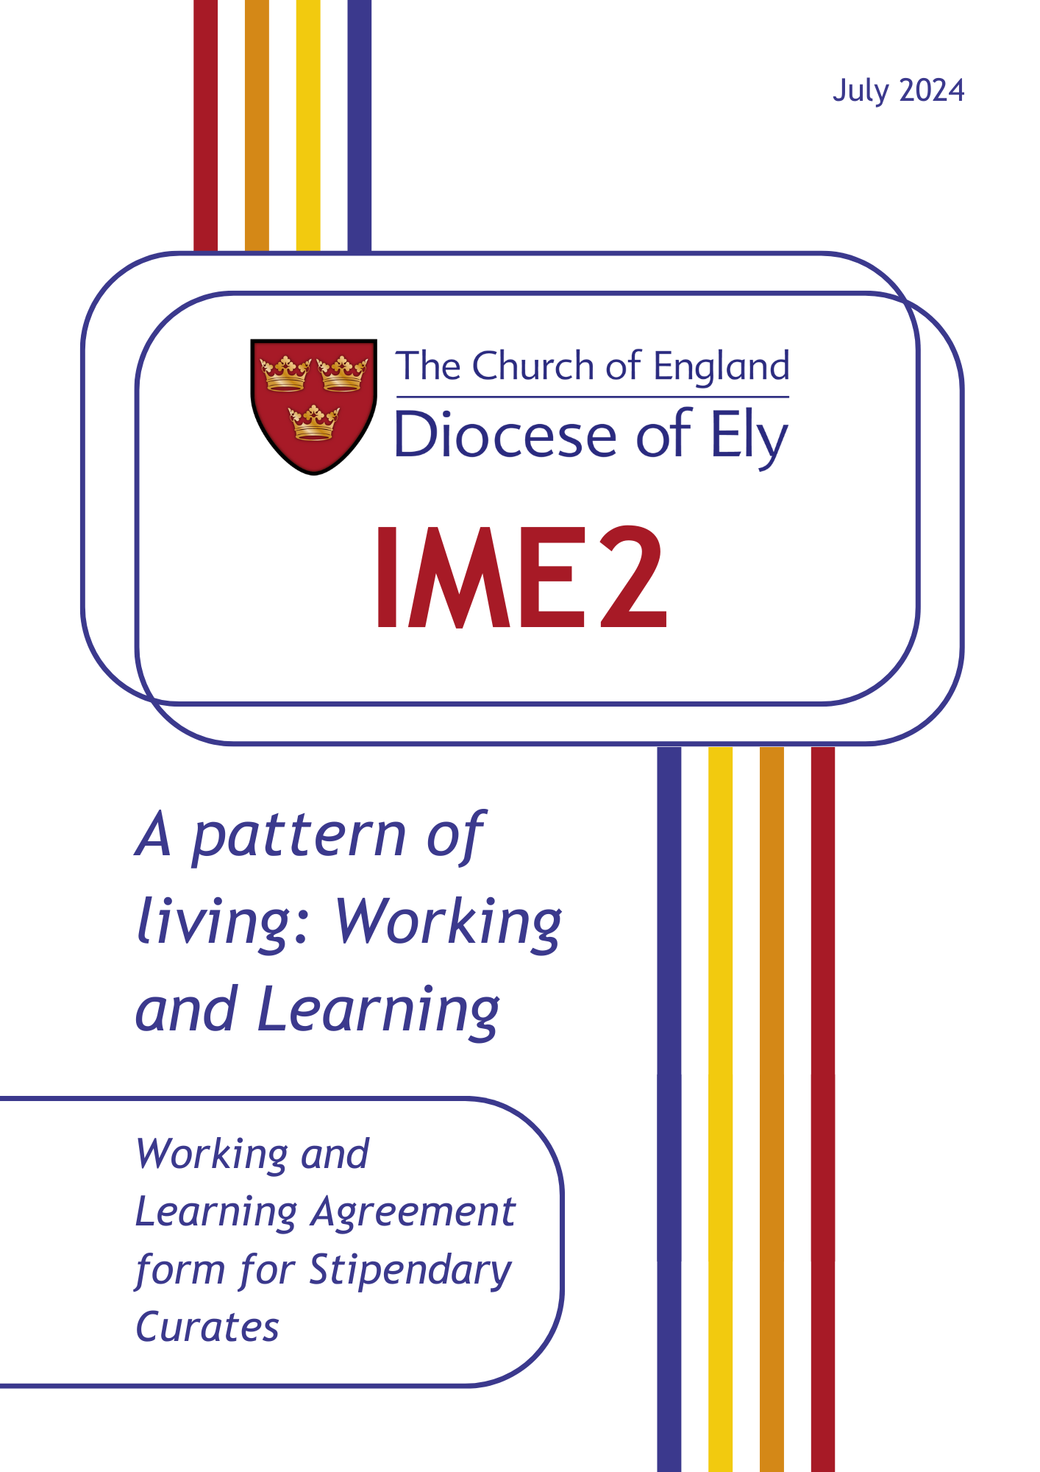

**A Pattern of Living**

**Working & Learning Agreement Form**

1. Benefice/Team Parish/Other place(s) of training post
2. Name of Training Incumbent
3. Name of Assistant Curate in training
4. Stipendiary (Full Time or Half-time)

The period of Title, which begins with ordination to the diaconate, will normally be no more than three years.

1. Please state the starting date of training post (See Section1 of your Statement of Particulars)
2. Please state the expected end date of training (See Section 2 of your Statement of Particulars)

Notes:

a. If a curate wishes to move to a new post before the end of three years, the bishop’s permission must be sought (after initial consultation with the Training Incumbent and the Director of Mission and Ministry) before any application is made.

b. The normal period of notice is three months.

**Pattern of Living: Working and Learning Agreement**

This is the ‘learning agreement’ referred to in section 1 of your Statement of Particulars for the training post.

The Pattern of Living: Working and Learning Agreement form is drawn up at the start of a curacy between training incumbent and curate, provides an initial basis for the new appointment.

It makes use of the notion of a ‘rule of life’ (with which not all will be familiar but) which points to two aspects of public ministry in the Church of England: first, the recognition that in ministry, as in Christian discipleship, it is important to have a framework for living which revitalizes and sustains; secondly, taking up the role of a public minister involves at ordination a commitment to working as those authorised within and by the Church. [See for instance: Hargrave, A. (2010). *Living Well: Finding a ‘Rule of Life’ to revitalize and sustain us.* London: SPCK.]

Such documents aim to provide a covenanted framework that is open and negotiated, to give confidence and clarity about expectations, particularly as a new working relationship gets under way. Such documents do not attempt to give a full or exact description of work or training to be undertaken. Neither are they static. Rather they need revision to reflect developments over time. As appropriate, the incumbent and curate are encouraged to share some or all the contents of this document with the PCC(s), Churchwardens or local ministry team.

**Note for action:** A draft copy of this Working and Learning Agreement is to be returned to the IME2 Training Officer by **the first week of October**, after ordination. This document is kept on file by the training incumbent, curate and the IME2 officer, along with the Director of Mission and Ministry and it forms part of the basis for periodic review.

A Pattern of Living (Working and Learning Agreement) incorporates the following:

A. An agreed working pattern

B. A framework for maintaining balance in relation to ministry, personal and home life (and secular employment), incorporating patterns of prayer, recreation and time off.

C. An agreed pattern for supervision for reflection on the practice of ministry and for ministerial development within the curacy.

D. Information about the diocesan IME Phase 2 framework of sessions for curates and meetings for briefing, review and assessment for training incumbents and curates.

E. Information about the Terms and Conditions of Service that relate to a curacy.

**Rule of Life (Working and Learning Agreement)**

**Section A:**

1. Overall Working Pattern

The normal expected pattern of working will be agreedbefore ordination between training incumbent and the curate, if necessary in consultation with the IME2 officer. The following points need to be taken into account:

**(for stipendiary or full-time curates)**

* the overall weekly pattern needs to reflect local conditions in deciding and safeguarding such matters as the curate’s **rest period [day off]**, expectations about **evening and Saturday working**;

**(for half-time curates, including those in secular employment)**

* those who are available for ministry on a half-time basis will have a working agreement which specifies the number of **sessions per week** [i.e. mornings, afternoons, evenings] involved, and expressed in terms of the number of **days per week** (on the basis that two sessions is counted as one day) being offered: **NB: once this figure is agreed it needs to be entered into section 3 of your Statement of Particulars**;
* for those in secular employment, account must be taken of both **work commitments** and any envisaged **ministry at work**;

**(for all curates)**

* the **agreed pattern**, including, where appropriate, sessions per week, may occasionally demand some degree of flexibility, but under normal circumstances must be respected.

Note:

1.a. The working pattern must take account of **personal circumstances** [See section 2 below], the **Initial Ministerial Education Phase 2**  programme [See section 5 below], and **personal study** [See section 6 below], as well as **rest periods** (as set out in section 9 of your Statement of Particulars).

**Description of agreed working pattern:** (where appropriate indicate the nature and extent of other than ministerial employment and any other agreed commitments that have been taken into account in agreeing this pattern)

1. Preaching

In the **first year**, the curate will be asked to preach **not more than twice a month on Sundays and at major festivals**. Indicate below the dates and services at with the Curate will preach during the first six months:

July-

August-

September-

October-

November-

December-

Notes:

2.a. Where possible there should be an early opportunity to preach at each of the different regular Sunday services in the Title post.

2.b. In 2nd and 3rd years, the expected level of preaching will be discussed and agreed.

1. Invitations to preach and minister outside the parish

Invitations to preach or to minister outside the parish may only be accepted after consultation with the training incumbent.

Please note here any such requests already received and whether or not they have been agreed:

Note:

3.a. A Sunday away on such activities does **not** count as a holiday Sunday.

1. Other liturgical involvement

The curate will be given sufficient opportunities to lead and take part in all forms of worship in the church (including occasional offices) for the diocesan guidelines for curates in training to be fulfilled.

Forms of worship available in the Title post:

Forms that are available elsewhere:

Notes:

4.a. This may involve opportunities being sought in other parishes/places. If this is needed the training incumbent will ensure that it is included in the Training Agenda and that arrangements are put in place.

1. Attendance at meetings

The curate will attend PCC and Deanery Chapter meetings and any meetings of synod which he/she is entitled to attend.

Dates ( Where known) of Meetings of PCC and Deanery Chapter and Synod in 1st year

PCC:

Chapter/ Synod:

Note:

5.a. as licensed clergy, curates are ex officio members of the PCC(s) in the benefice where they serve and of the Deanery Synod.

6. Staff Meetings

The curate will attend meetings of the ministerial team in the pattern developed locally.

Pattern of ministerial team meetings and note of those attending:

7. Fees(See item 4 of your Statement of Particulars)

All fees for weddings, burials, cremation services, etc. are to be passed on to the PCC who will assign them at the appropriate time to the diocese.

Note:

7.a. Any fees arising from weddings, burials, cremation services, etc. taken outside

the benefice must be assigned to the diocese.

8. Expenses

You are entitled to the reimbursement of expenses reasonably incurred in connection with the exercise of your office. Reimbursement is the responsibility of the Parochial Church Council(s) of the parish(es) in which you serve.

Types of expense:

Basis of Claim:

Notes:

8.a. A curate who is not resident in the benefice of the Title may be able to have car mileage from their house to benefice boundary reimbursed, subject to negotiation with the Director of Mission and Ministry. The PCC(s) will pay for car mileage from within the benefice.

8.b. For further details see: The Parochial Expenses of the Clergy: a guide to their reimbursement published by the Central Stipends Authority (downloadable from [www.churchofengland.org](http://www.churchofengland.org) ).

9. Ongoing Study

Time is to be set aside each week for **personal study**. This should be the equivalent of **one morning a week** for full-time curates, on a fixed or variable basis. Others should agree a pro rata equivalent.

Priority in terms of ongoing study, at the start of the curacy, is to be given to any relevant items referred to in the final pre-ordination training report, or any continuing study commitments that have been agreed to with the diocese and the training incumbent before ordination. Other items, of areas of theology and/or disciplines related to the practice of mission and ministry, should be of the curate’s choosing.

|  |
| --- |
| Items in final training report: |
| Agreed ongoing study programme: |
| Other: |

**Section B:**

10. Work-Life Balance

Description of the family **circumstances** of curates who are married and the non-work patterns of those who are single, noting any particular matters (such as work, education, health, other major commitments of household members) that are likely to have a material effect on the curate’s working pattern or are in other ways a significant cause for **concern**:

A **note** should be added of any agreement reached as to how these will be taken into account between the training incumbent and the curate.

|  |
| --- |
| Circumstances: |
| Concerns: |
| Note: |

Note:

10.a. A confidential counselling service is available for clergy and their families. Contact [bruce.kinsey@cantab.net](mailto:bruce.kinsey@cantab.net)

11. Patterns for praying

Training Incumbent and Curate: A pattern of times and meeting place for prayer will be agreed with the training incumbent. Times may be changed by mutual agreement. This should complement the pattern of individual prayer the curate is establishing.

Agreed pattern:

Curate’s weekly pattern of personal prayer, of quiet days and retreats, and meetings with peer (cell) group, if any:

Name of curate’s spiritual director / soul friend or equivalent and usual pattern of meetings, with date of next meeting noted:

Note:

11.a. Any curate who needs help to find a (new) spiritual director should contact Revd Jane Keiller, Diocesan Officer for Spirituality on [jane.keiller@gmail.com](mailto:jane.keiller@gmail.com)

12. Annual Leave

The full-time entitlement is 36 days annual leave (pro rata for half-time). [For further details see section 9 of your Statement of Particulars.]

Please note the holiday dates that have been agreed for the Curate in the period from July to June:

If some remain to be agreed, please note by when this is to be done:

Note:

12.a. For those ordained at Petertide, the holiday entitlement for the remainder of this year is eighteen days.

12b. Holiday entitlement should not be used for the Ordination or other periods of Retreat.

13. Sick Leave, Maternity, Paternity and Adoption Leave

See sections 9 and 10 of your Statement of Particulars

**Section C:**

14. Supervision

**Meetings for Supervision** aredesigned to assist the curate to reflect on the experience of ministry and to take the development agenda forward.

The training incumbent and curate are strongly advised to meet weekly or fortnightly initially and at least monthlyfor half-time curates for **a supervision session on an occasion separate from a staff meeting**, This will also provide a place for training incumbent and curate to explore matters such as expectations, ideas of authority and delegation, understandings of good practice in relation to confidentiality, diversity of theological and spiritual perspective.

Pattern of meetings and note of any dates arranged:

Training incumbents are provided with ongoing support and training to assist with their practice of supervision. The TI is asked to complete the following details:

|  |  |
| --- | --- |
| TI’s work supervision provided by the diocese | (give details e.g. when, with whom etc) |
| Other arrangement (e.g. other training for supervision attended*,* membership of supervision group etc) | (give details) |

**Section D:**

15. IME Phase 2 Framework

The IME Phase 2 programme is the diocesan provision of Continuing Ministerial Education, referred to in section 8 of your Statement of Particulars, for the first three years of curacy.

**The training incumbent is to ensure that the curate is free of parochial commitments for the sessions of IME Phase 2.**

Should the curate intend for any reason not to attend an IME Phase 2 session he/she should email the IME2 (Curate Training) Officer (steven.rothwell@elydiocese.org) to negotiate permission to be absent.

Curates are expected to attend all the sessions of the annual IME phase 2 programme during the first three years of ministry. Some of the sessions will be shared with Licensed Lay Ministers.

Notes:

15.a. It is the responsibility of the training incumbent to ensure that there are no parochial commitments planned for the curate which would prevent attendance at IME Phase 2.

15.b. Pastoral and parochial commitments which arise at short notice should

wherever possible be agreed to at times which enable attendance at IME Phase 2.

All curates are advised to keep a personal learning journal, into which is kept an ongoing reflection of curacy with evidence of ministry such as service sheets, sermon outline etc. This will help when completing end of year assessments.

16. Briefing, Review and Assessment Meetings

The timetable for the next three years is as follows:

By end of April, end of year one:

1. End of year Formation and Review Reflection form completed and sent to Bishop, IME2 officer and Director of Mission and Ministry.
2. Curate completes theological reflection essay (2,500 words)
3. Training Incumbent to write to Bishop confirming their recommendation for the curate to proceed to priesting.

By June, end of year two:

1. End of year Formation and Review Reflection form updated and sent to Bishop, IME2 officer and Director of Mission and Ministry.
2. Curate completes basic CV-style form for Archdeacon.

ii) Curate completes theological reflection essay (2,500 words).

Final Year process:

1. End of curacy paperwork completed by curate and Training Incumbent in readiness for signing off in January of final year.
2. Curate undertakes a 4-week Placement at any point during final year.
3. Signing off meeting with curate, Bishop, IME2 officer and Training Incumbent. In January of final year.

Note:

16.a. These meetings constitute the provision for Ministerial Development Review (referred to in section 7 of your Statement of Particulars) for the first three years of curacy. The first meeting within the Bishop’s annual framework for the Review of Ministry (for parochially licensed clergy) takes place within eighteen months of taking up a further post under common tenure once the training post has been completed, and annually thereafter.

17. Vacancy

Should a vacancy in the incumbency arise during the curate’s Title appointment, consultation must take place with the Director of Mission & Ministry about arrangements for the supervision and support of the curate.

If a curate is in post when a vacancy is filled, the Working Agreement must be re-negotiated with the incoming Incumbent/Team Rector.

18.

Please note below any items from the above list that remain to be clarified or about which agreement has not yet been reached, noting what action is being taken or what help is needed or being sought, together with the date by which matters are expected to be resolved.

**Item Action/ Help By when**

Signed: ………….………………..………………………… (Incumbent/Team Rector)

Signed: ………………………………….……………………………………… (Curate)

Signed: ……………………………………………………….. (Curate Training Officer)

Date: …..…………………………………..………………………………..………